Agenda

- The Chairman’s Welcome
- Welcome to the New Clerk
- Attendance and Apologies for absence
- Minutes of the last meeting held on the 7 November 2022
- Matters arising
- Declarations of Interest
- Public participation session
- Finance:
- Parking paid in to date, this financial year £
- Pearson Smith tree works £260 Chq 711
- Elliott Consultancy £462 Chq 712
- Q3 Clerk Salary £296.50 Chq 713
- Q3 Tax £74 Chq 714
- Village Hall November hire £4.50 Chq 715
- Q3 Autela payroll £30.22 Chq 716

- Planning Applications: None
- Salt Bin Dark Lane
- Street Light Friars Hill
- Tree Inspection Report
- AOB

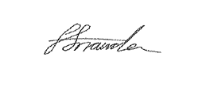
Faye Snowden - Clerk & Responsible Financial Officer

All residents are welcome to attend, please contact the Clerk with any questions.

