Agenda

- The Chairman’s Welcome
- Attendance and Apologies for absence
- Minutes of the last meeting held on the 18 July 2022
- Matters arising
- Declarations of Interest
- Public participation session
- Finance:
- Parking paid in to date, this financial year £837
- CIL received £1211.25
- PC Laptop £429.00 Chq 701
- Clerk salary £296.30 Chq 702
- Clerk tax £74.20 Chq 703
- Autela payroll £30.46 Chq 704

- Planning Applications:
22/00916/FUL – Land adj Riverdell Main Street – No objection
- Daffodils
- Himalayan Balsam
- Village Green Parking
- AOB

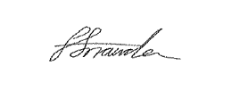
Faye Snowden - Clerk & Responsible Financial Officer

All residents are welcome to attend, please contact the Clerk with any questions.

