Agenda

- The Chairman’s Welcome
- Attendance and Apologies for absence
- Minutes of the last meeting held on the 24 May 2022
- Matters arising
- Declarations of Interest
- Public participation session
- Finance:
- Parking paid in to date, this financial year £541.70
- Q1 Salary £296.50 Chq 693
- Q1 Tax £74.00 Chq 682
- Garth Lease for 2022/2023 £10.00 Chq 694
- Village Hall Hire April/May £17.00 Chq 695
- Q1 Payroll £42.85 Chq 696

- Planning Applications:
22/00542/FUL – 1 & 2 Catterbeck, Lime Road, Little Edstone – No Objection
22/00175/FUL – Fox and Hounds Country Hotel -
- Daffodils
- Footbridge
- Railings
- Riverbank Grass Cutting - Request to delay & Individuals cutting
- Request to use green for exercise class
- Laptop
- AOB

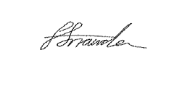
Faye Snowden - Clerk & Responsible Financial Officer

All residents are welcome to attend, please contact the Clerk with any questions.

