Agenda

- The Chairman’s Welcome
- Attendance and Apologies for absence
- Minutes of the last meeting held on the 24 January 2022
- Matters arising
- Declarations of Interest
- Finance:
- Parking paid in to date, this financial year £1347.71
- Q4 Salary £279.99 Chq 683 tbc
- Q4 Tax £70.00 Chq 684 tbc
- Q4 Payroll £30.00 Chq 685 tbc

- Planning Applications:
NYM/2022/0052 – Friars Hill Cottage West, Sinnington – No Objection
22/00175/FUL – Fox and Hounds, Sinnington -
- Interpretation board
- Asset Register
- AOB

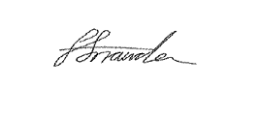
Faye Snowden - Clerk & Responsible Financial Officer

All residents are welcome to attend, please contact the Clerk with any questions.

