Agenda

- The Chairman’s Welcome
- Attendance and Apologies for absence
- Minutes of the last meeting held on the 1 November 2021
- Matters arising
- Declarations of Interest
- Parish Precept
- Finance:
- Parking paid in to date, this financial year £1114.92
- Q Payroll Autela £30.00 Chq 6
- Christmas Tree Donation £50.00 Chq 679
- Q3 Salary £279.99 Chq 680
- Q3 Tax £70.00 Chq 681
- Q3 Payroll £30.00 Chq 682

- Planning Applications:
NYM/2021/0643/Fl – Low Hall, Riverside, Sinnington – No Objection
20/01580/CLEUD – Fox and Hounds Country Hotel, Sinnington –
NYM/2021/0958/FL – Woodlands, Moor Lane, Sinnington – No Objection
- Grit Bin Main Street
- Interpretation board
- AOB

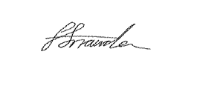
Faye Snowden - Clerk & Responsible Financial Officer

All residents are welcome to attend, please contact the Clerk with any questions.

