Agenda

- The Chairman’s Welcome
- Attendance and Apologies for absence
- Minutes of the last meeting held on the 20 September 2021
- Matters arising
- Declarations of Interest
- Finance:
- Parking paid in to date, this financial year £1114.92
- Wilson Joinery Donation Box £28.96 Chq 672
- Q2 Payroll Autela £30.00 Chq 673
- Mower £2999 Chq 675
- Petrol donations Cash £50
- Baldwin Green £630 Chq 676
- Downson Hedge cutting £57.60 Chq 677
- Village Hall hire £21.00 Chq 678

- Planning Applications:
RYE-2018-02-DO – Consultation for Highways Act 1980 Public Path Diversion.
- Footpath and Bridleway Map
- Pick up after your dog signage
- Lady Lumleys Education Foundation
- 2022 Meeting Dates
- AOB

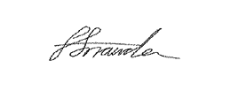
Faye Snowden - Clerk & Responsible Financial Officer

All residents are welcome to attend, please contact the Clerk with any questions.

