Agenda

- The Chairman’s Welcome
- Attendance and Apologies for absence
- Minutes of the last meeting held on the 19 July 2021
- Matters arising
- Declarations of Interest
- Trees on the Stripe
- Finance:
- Parking paid in to date, this financial year £946.42
- Computer Service and Microsoft Software £164.99 Chq 669
- Q2 Clerk Salary £279.99 Chq 670
- Q2 Clerk Tax £70 Chq 671

- Planning Applications:
- 21/01052/FUL – 2 Church Row, The Green -
- Lady Lumley’s Trust
- River Bank
- Lawn Mower
- AOB

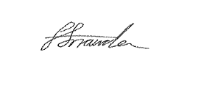
Faye Snowden - Clerk & Responsible Financial Officer

All residents are welcome to attend, please contact the Clerk with any questions.

